USE CASES Diagram
ProfileBook
Venkata Sai Rehan
SRM AP
Login:
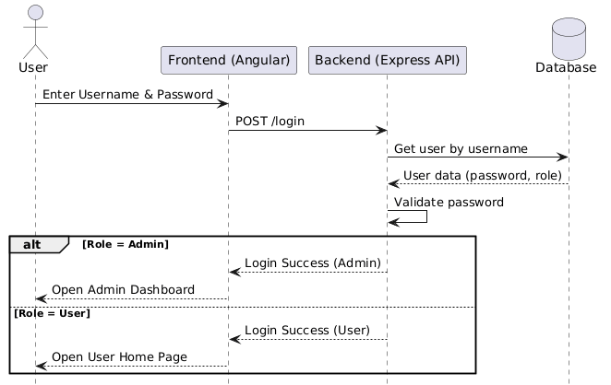

login
- The user enters email and password on the login page.
- The backend checks the credentials in the Users table in the database.
- If valid, the system logs the user in and redirects based on role (Admin/User).

Signup:
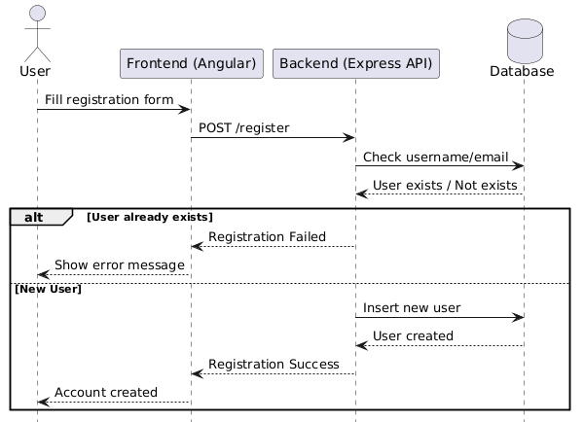

Signup (New User Register):
- The user fills the registration form with username, email, password, and mobile number.
- The Controller validates inputs such as password format, email uniqueness, and required fields.
- If validation succeeds, then the backend stores the new user in the Users table.

Posts:
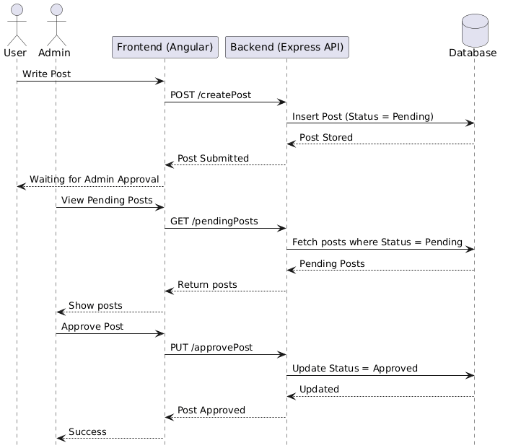 Create Post
- The user writes content and optionally uploads an image.
- The frontend sends the post data to the backend API.
- The backend saves the post in the Posts table with status = Pending
Post Has Post_ID,USER_ID,Content_Post_Imgage,Status.
Messages:
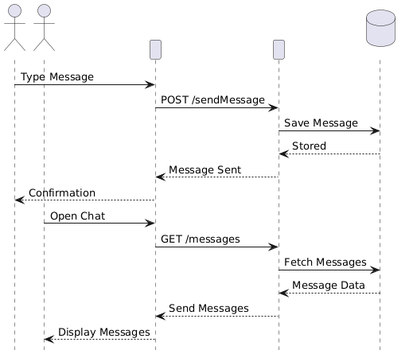
- A user types a message and selects another user to send it to.
- The frontend sends the message to the backend API, which stores it in the Messages table.
- The receiver fetches and views the message in the chat interface.
It contains:
Message_id,Sender_ID,Receiver_ID,MessageContent,TimeStamp of the message.
Report User:
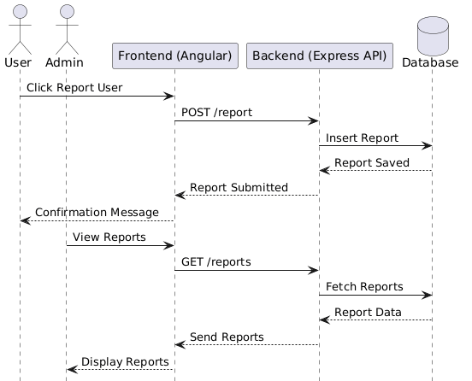

Report User:
- A user reports another user for inappropriate behavior or content.
- The system records the report details in the Reports table with the reason and timestamp.
- The admin reviews these reports and takes appropriate action.
Search User:
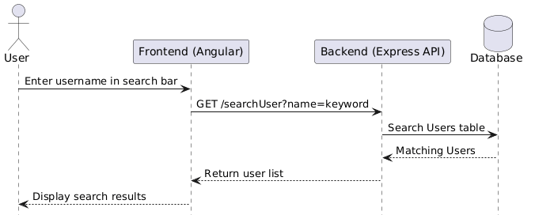

Search Users:

- Users search other users using their usernames and usernames fetched from db.

